Executive Post Graduate Certification in Cloud
Computing and DevOps – Project
DevOps
Assignment: Pipeline creation for Website deployment
Objective: The objective of this assignment is to create a Pipeline for the
deployment of our Website.
DevOps
1. Setting up Terraform and creating the required Infrastructure:
○ Create an Instance in AWS which will be acting as the Terraform
Master machine.
○ Create a VPC and a Subnet in that VPC.
○ Create 3 Instances in that Subnet.
2. Setting Ansible up:
○ Install Ansible in the same machine where Terraform was installed.
○ Setup Ansible up, i.e. create the connection between the Ansible
Master and the Slaves.
3. Creating the Ansible configuration:
○ One of the 3 machines created using Terraform will be behaving as
the Master for Jenkins
○ The other will be the Kubernetes Master machine which will be
required to be added as a Kubernetes Agent in the Jenkins
Dashboard.
○ The final Machine created via Terraform will be acting as the
Kubernetes Slave Machine.
4. Setting Jenkins up:
○ Setup the Jenkins Dashboard.
○ Create the Ansible Slave Machine as an Agent in the Jenkins
Dashboard which was setup as the Kubernetes Master node.
5. Setting up the GitHub repository provided below:
○ The GitHub repository that has to be set up is
https://github.com/mdn/beginner-html-site-styled
○ Fork the repository on your end and use that forked repository for
the rest of the Assignment.

○ Create the Dockerfile required in order to containerize the Website
that has been provided as well.
○ A deployment file that will create the required deployment from the
image which will be created from the Dockerfile and uploaded to
DockerHub. The deployment will have a total of 5 replicas.
○ A service file which will be of type NodePort which will expose the
above mentioned deployment on port 30010.
6. Create the Jenkins Pipeline:
○ A Jenkinsfile has to be created that will be included in the forked
repository.
○ The Jenkinsfile should build a new image pushed to Dockerub upon
changes to the repository to ensure that the latest website is
displayed at all times.
○ This Pipeline will create the deployment from the Manifest file
present in the GitHub repository and expose it using the NodePort
Service file created.
○ The Jenkins pipeline which will be created should be automatically
triggered once changes are made to the forked repository.
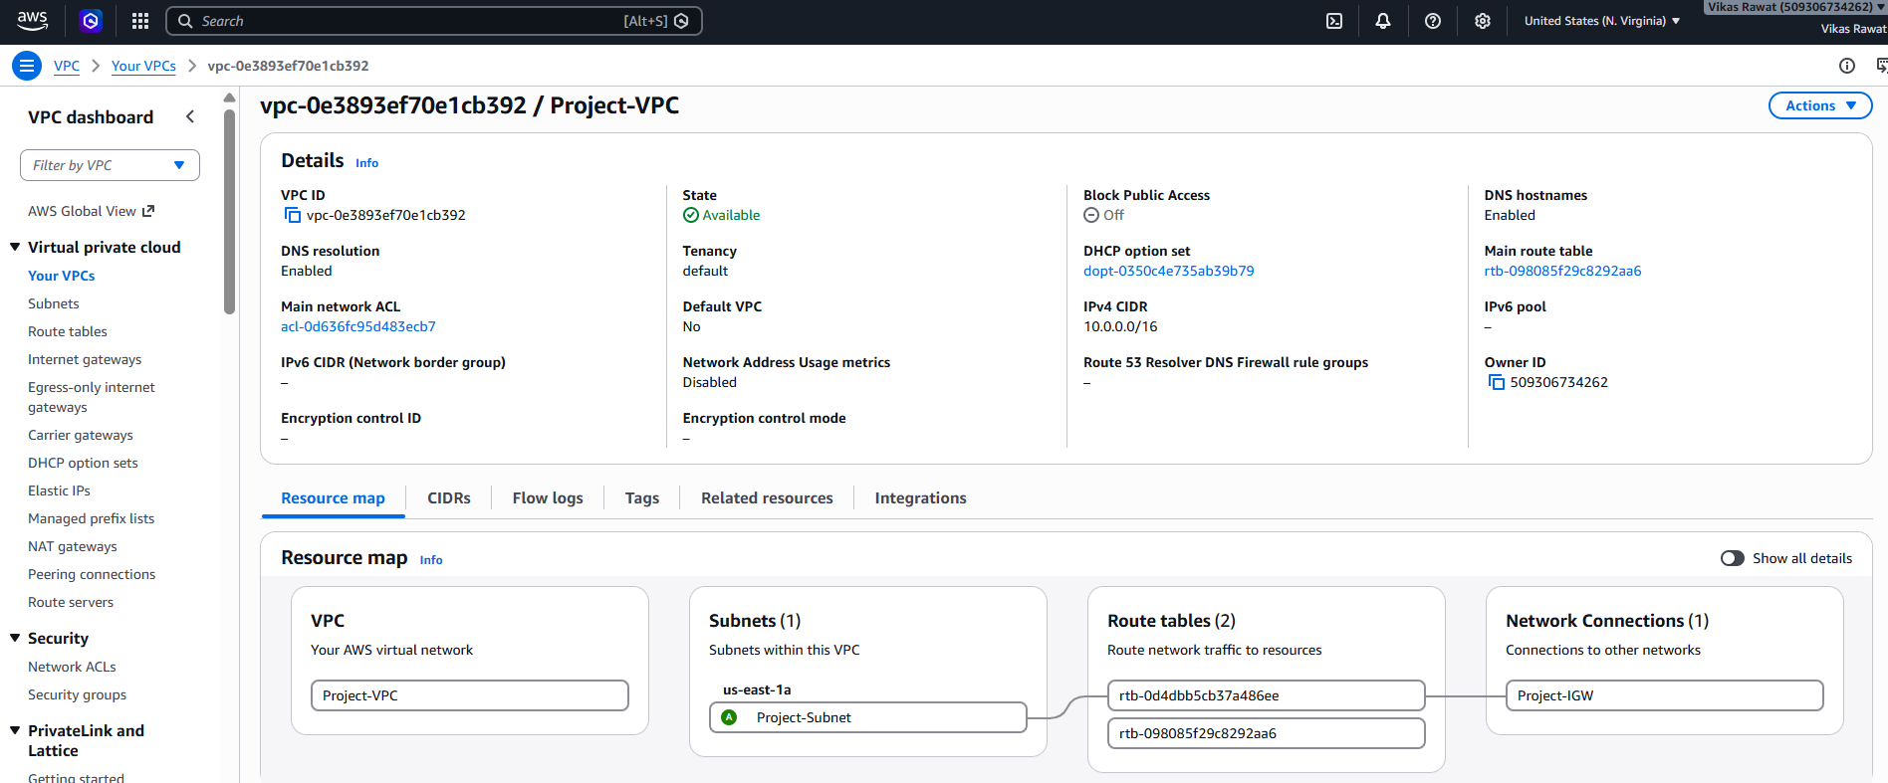
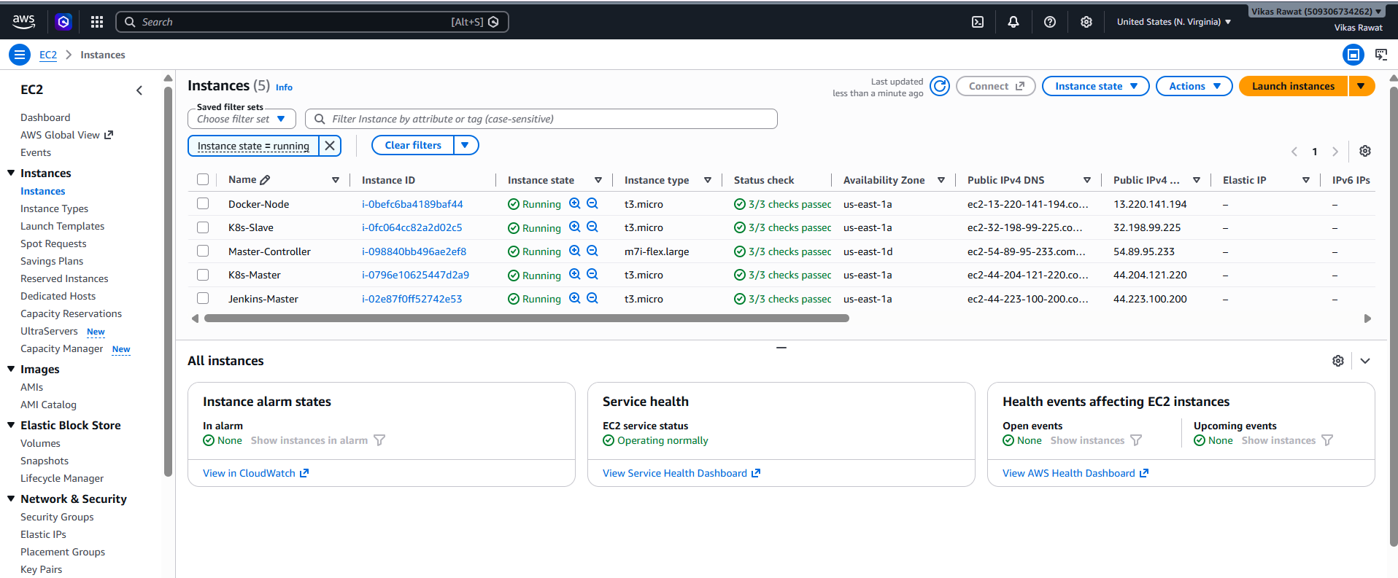
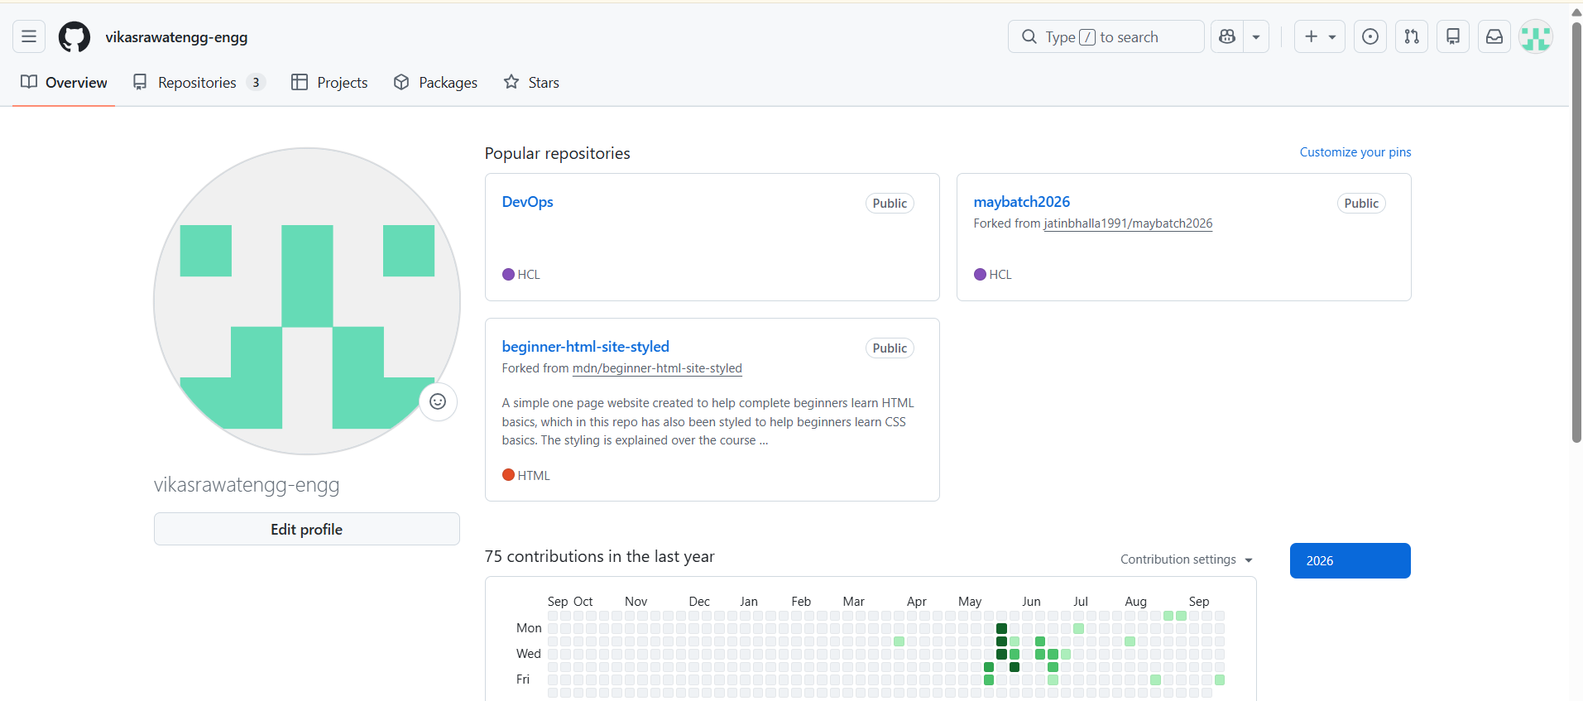
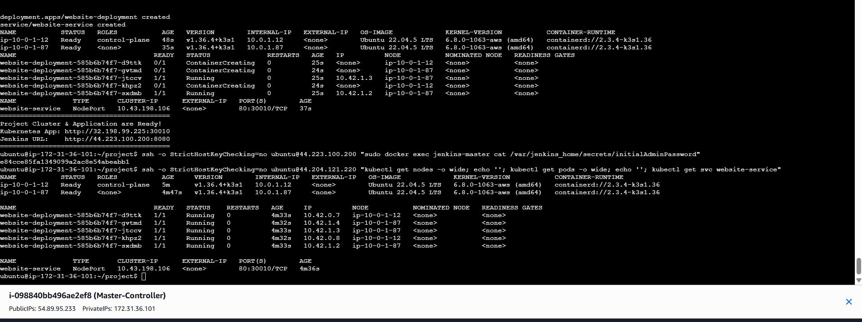
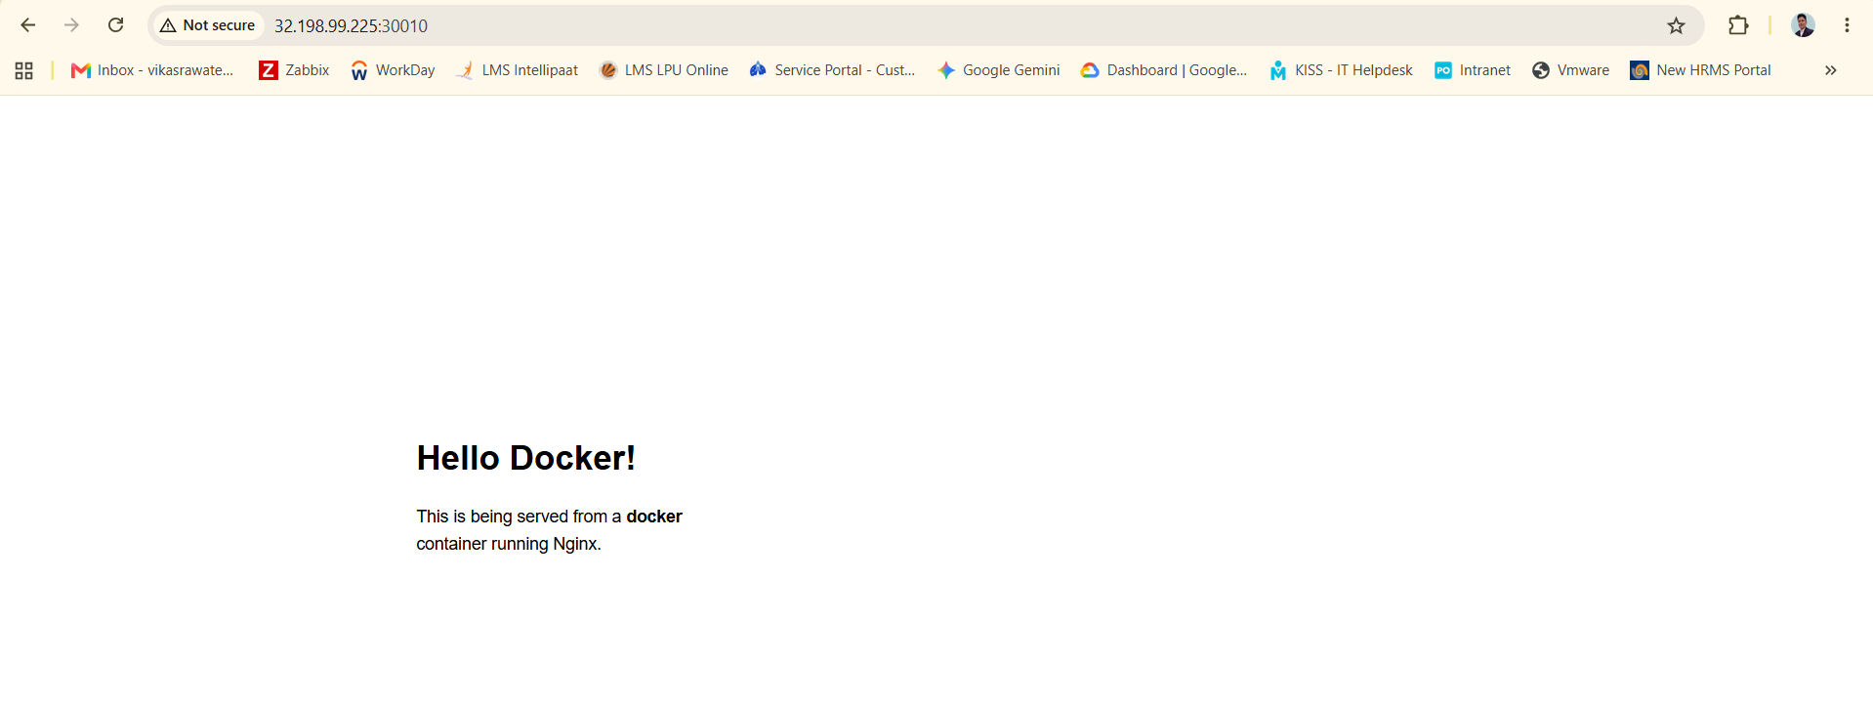
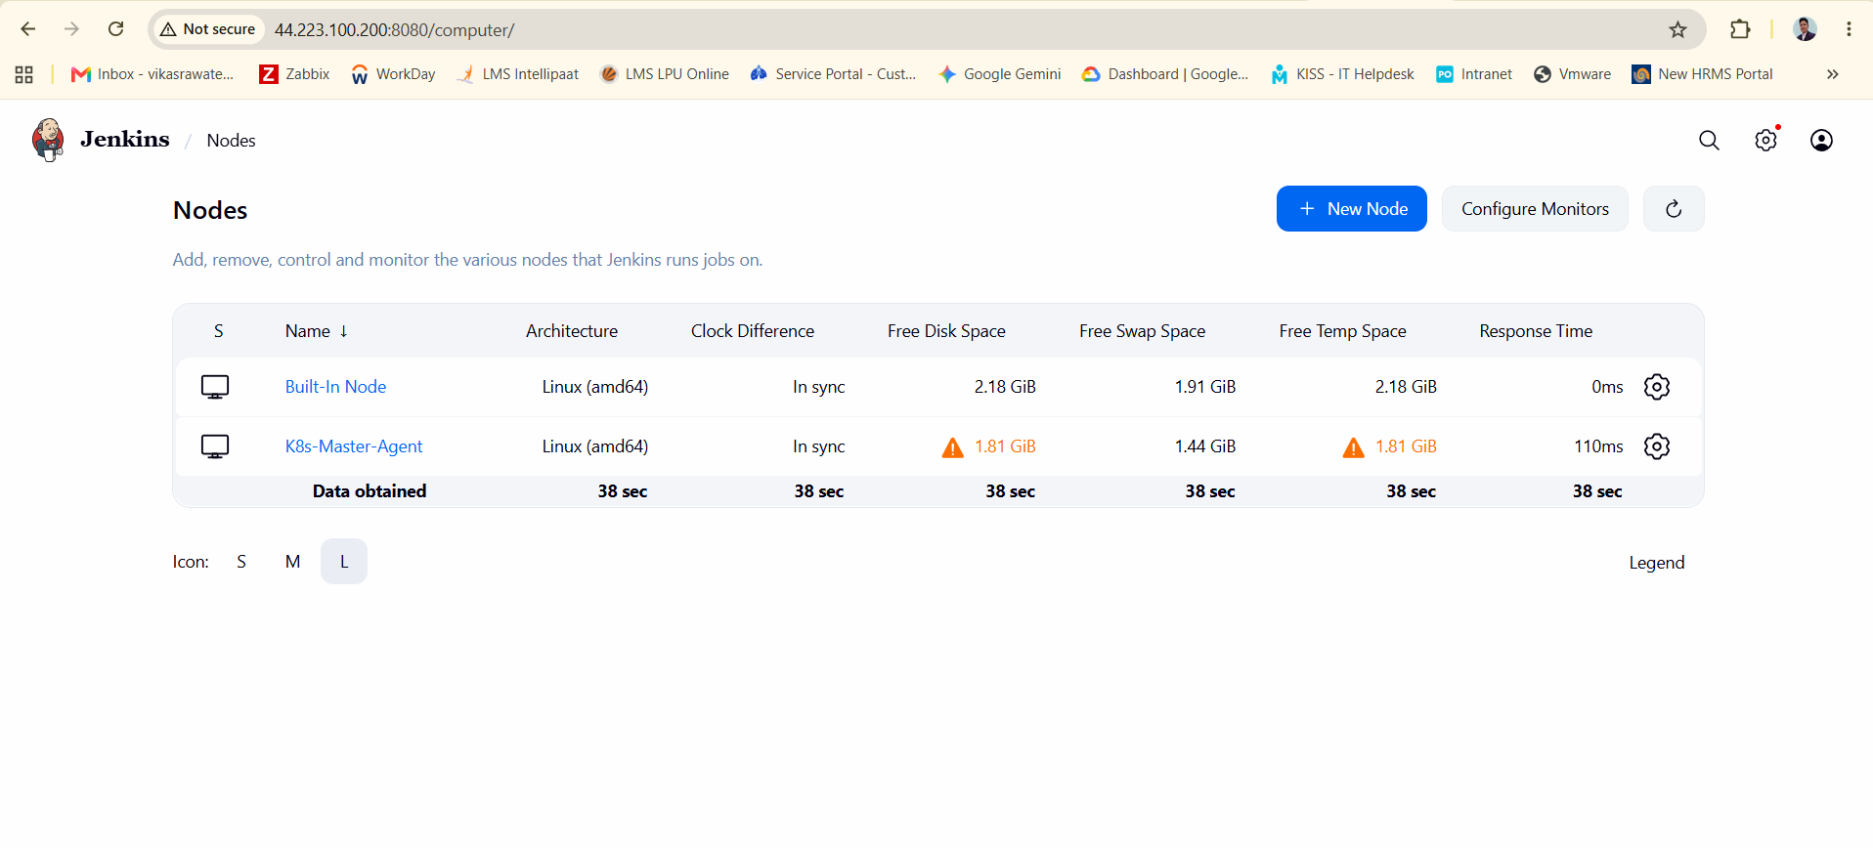
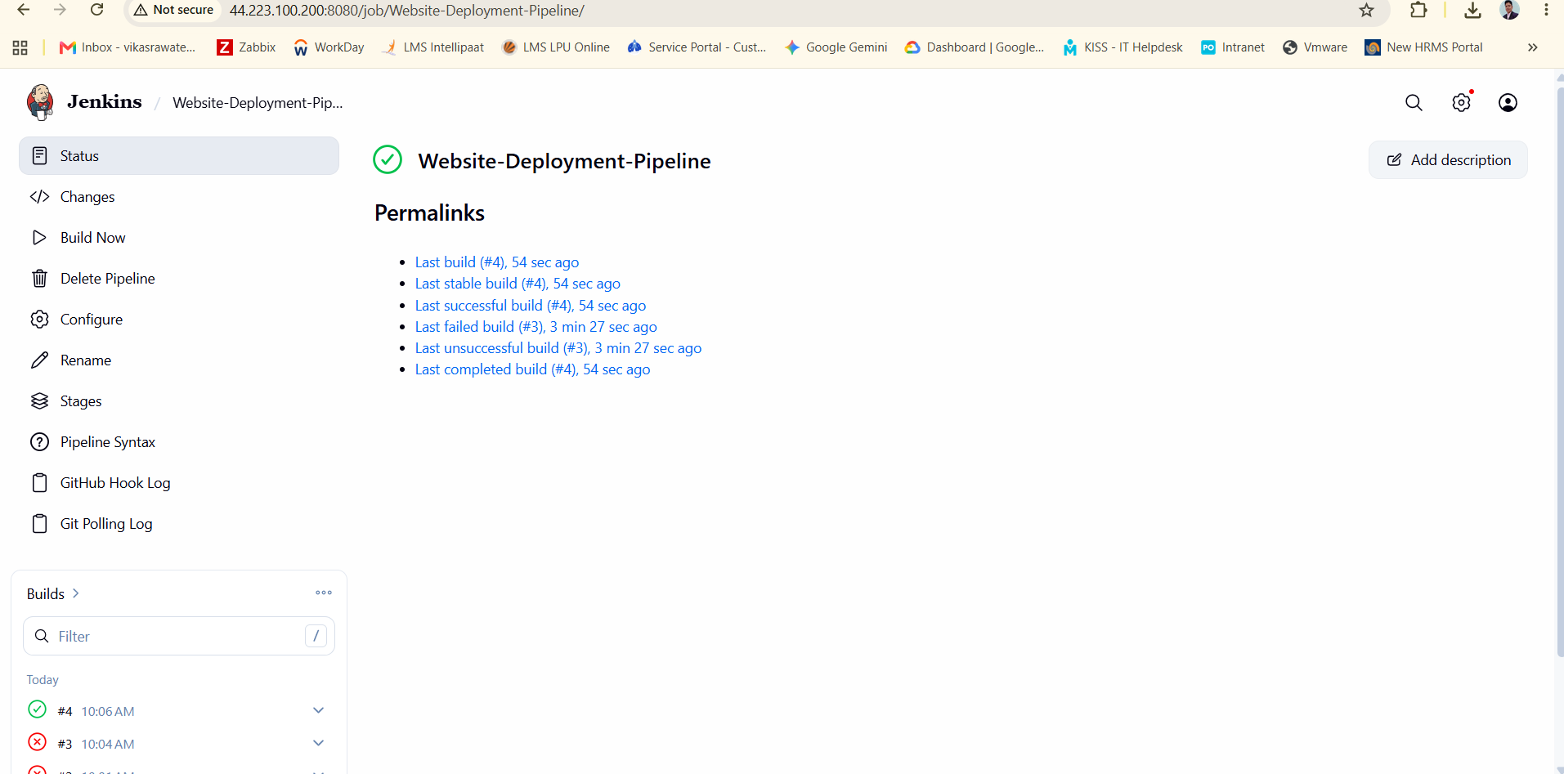
Started by user admin
Obtained Jenkinsfile from git https://github.com/vikasrawatengg-engg/beginner-html-site-styled
[Pipeline] Start of Pipeline
[Pipeline] node
Running on K8s-Master-Agent in /home/ubuntu/workspace/Website-Deployment-Pipeline
[Pipeline] {
[Pipeline] stage
[Pipeline] { (Declarative: Checkout SCM)
[Pipeline] checkout
Selected Git installation does not exist. Using Default
The recommended git tool is: NONE
using credential dockerhub-credentials
> git rev-parse --resolve-git-dir /home/ubuntu/workspace/Website-Deployment-Pipeline/.git # timeout=10
Fetching changes from the remote Git repository
> git config remote.origin.url https://github.com/vikasrawatengg-engg/beginner-html-site-styled # timeout=10
Fetching upstream changes from https://github.com/vikasrawatengg-engg/beginner-html-site-styled
> git --version # timeout=10
> git --version # 'git version 2.34.1'
using GIT_ASKPASS to set credentials
> git fetch --tags --force --progress -- https://github.com/vikasrawatengg-engg/beginner-html-site-styled +refs/heads/*:refs/remotes/origin/* # timeout=10
Checking out Revision df8b23deb6edca4cb8ebeae0c2ebc1bd79015337 (refs/remotes/origin/main)
Commit message: "Update deployment.yaml"
> git rev-parse refs/remotes/origin/main^{commit} # timeout=10
> git config core.sparsecheckout # timeout=10
> git checkout -f df8b23deb6edca4cb8ebeae0c2ebc1bd79015337 # timeout=10
> git rev-list --no-walk df8b23deb6edca4cb8ebeae0c2ebc1bd79015337 # timeout=10
[Pipeline] }
[Pipeline] // stage
[Pipeline] withEnv
[Pipeline] {
[Pipeline] withEnv
[Pipeline] {
[Pipeline] stage
[Pipeline] { (Checkout Code)
[Pipeline] checkout
Selected Git installation does not exist. Using Default
The recommended git tool is: NONE
using credential dockerhub-credentials
Fetching changes from the remote Git repository
Checking out Revision df8b23deb6edca4cb8ebeae0c2ebc1bd79015337 (refs/remotes/origin/main)
Commit message: "Update deployment.yaml"
[Pipeline] }
[Pipeline] // stage
[Pipeline] stage
[Pipeline] { (Build Docker Image)
[Pipeline] sh
> git rev-parse --resolve-git-dir /home/ubuntu/workspace/Website-Deployment-Pipeline/.git # timeout=10
> git config remote.origin.url https://github.com/vikasrawatengg-engg/beginner-html-site-styled # timeout=10
Fetching upstream changes from https://github.com/vikasrawatengg-engg/beginner-html-site-styled
> git --version # timeout=10
> git --version # 'git version 2.34.1'
using GIT_ASKPASS to set credentials
> git fetch --tags --force --progress -- https://github.com/vikasrawatengg-engg/beginner-html-site-styled +refs/heads/*:refs/remotes/origin/* # timeout=10
> git rev-parse refs/remotes/origin/main^{commit} # timeout=10
> git config core.sparsecheckout # timeout=10
> git checkout -f df8b23deb6edca4cb8ebeae0c2ebc1bd79015337 # timeout=10
+ docker build -t vikasrawatengg/beginner-site:latest .
DEPRECATED: The legacy builder is deprecated and will be removed in a future release.
Install the buildx component to build images with BuildKit:
https://docs.docker.com/go/buildx/

Sending build context to Docker daemon 396.8kB

Step 1/4 : FROM nginx:alpine
alpine: Pulling from library/nginx
e72112c14215: Pulling fs layer
e2de96513ba9: Pulling fs layer
d9aae54b5831: Pulling fs layer
6c53d0b2a666: Pulling fs layer
745dfb2690dd: Pulling fs layer
9a9a644fdd6a: Pulling fs layer
64c8194480fe: Pulling fs layer
e76228b47809: Pulling fs layer
0deea27e58d9: Download complete
745dfb2690dd: Download complete
d54d3939625e: Download complete
6c53d0b2a666: Download complete
9a9a644fdd6a: Download complete
e76228b47809: Download complete
64c8194480fe: Download complete
e2de96513ba9: Download complete
d9aae54b5831: Download complete
e72112c14215: Download complete
e2de96513ba9: Pull complete
6c53d0b2a666: Pull complete
d9aae54b5831: Pull complete
745dfb2690dd: Pull complete
9a9a644fdd6a: Pull complete
e76228b47809: Pull complete
64c8194480fe: Pull complete
e72112c14215: Pull complete
Digest: sha256:1ed1b0e1d7652937d6cbdaf4018c7b6fc009a7dd6c3047351e2eddda745de43f
Status: Downloaded newer image for nginx:alpine
---> 1ed1b0e1d765
Step 2/4 : COPY . /usr/share/nginx/html/
---> 3f2c75ba8175
Step 3/4 : EXPOSE 80
---> Running in 0334adda3b67
---> Removed intermediate container 0334adda3b67
---> a8969bdf6334
Step 4/4 : CMD ["nginx", "-g", "daemon off;"]
---> Running in a1bf1ebd98a5
---> Removed intermediate container a1bf1ebd98a5
---> 56bc4ac32121
Successfully built 56bc4ac32121
Successfully tagged vikasrawatengg/beginner-site:latest
[Pipeline] }
[Pipeline] // stage
[Pipeline] stage
[Pipeline] { (Push to DockerHub)
[Pipeline] withCredentials
Masking supported pattern matches of $DOCKER_PASS
[Pipeline] {
[Pipeline] sh
+ echo ****
+ docker login -u vikasrawatengg@gmail.com --password-stdin

WARNING! Your credentials are stored unencrypted in '/home/ubuntu/.docker/config.json'.
Configure a credential helper to remove this warning. See
https://docs.docker.com/go/credential-store/

Login Succeeded
[Pipeline] sh
+ docker push vikasrawatengg/beginner-site:latest
The push refers to repository [docker.io/vikasrawatengg/beginner-site]
64c8194480fe: Waiting
e76228b47809: Waiting
e72112c14215: Waiting
0eee6987bdac: Waiting
e2de96513ba9: Waiting
9a9a644fdd6a: Waiting
d9aae54b5831: Waiting
745dfb2690dd: Waiting
6c53d0b2a666: Waiting
e76228b47809: Waiting
e72112c14215: Waiting
0eee6987bdac: Waiting
e2de96513ba9: Waiting
9a9a644fdd6a: Waiting
d9aae54b5831: Waiting
745dfb2690dd: Waiting
6c53d0b2a666: Waiting
64c8194480fe: Waiting
6c53d0b2a666: Waiting
64c8194480fe: Waiting
e76228b47809: Mounted from library/nginx
e72112c14215: Mounted from library/nginx
e2de96513ba9: Mounted from library/nginx
9a9a644fdd6a: Mounted from library/nginx
d9aae54b5831: Waiting
745dfb2690dd: Mounted from library/nginx
6c53d0b2a666: Mounted from library/nginx
64c8194480fe: Mounted from library/nginx
d9aae54b5831: Mounted from library/nginx
0eee6987bdac: Pushed
latest: digest: sha256:56bc4ac32121a3ed8629150bff89b0b40e4fc91e2b3bd27693e104c266d8ae55 size: 2264
[Pipeline] }
[Pipeline] // withCredentials
[Pipeline] }
[Pipeline] // stage
[Pipeline] stage
[Pipeline] { (Deploy to Kubernetes)
[Pipeline] sh
+ kubectl apply -f k8s/deployment.yaml
deployment.apps/website-deployment configured
[Pipeline] sh
+ kubectl apply -f k8s/service.yaml
service/website-service unchanged
[Pipeline] sh
+ kubectl rollout restart deployment/website-deployment
deployment.apps/website-deployment restarted
[Pipeline] }
[Pipeline] // stage
[Pipeline] }
[Pipeline] // withEnv
[Pipeline] }
[Pipeline] // withEnv
[Pipeline] }
[Pipeline] // node
[Pipeline] End of Pipeline
Finished: SUCCESS

